**EUCOBAR and EUCOBAR RTU**

Surface Applied Evaporation Retarder

EUCOBAR is designed to be used as an evaporation retardant and finishing aid on concrete surfaces of all types. When sprayed over fresh concrete, EUCOBAR forms a monomolecular film that prevents rapid moisture loss from the concrete surface. Standard EUCOBAR is supplied as a concentrate and is diluted in the field. EUCOBAR RTU is supplied pre-diluted, and does not require the addition of water before using.

{Note to Specifier: The paragraphs below are meant to be incorporated into a standard CSI 3 Part Format specification (normally 03 30 00), the General Structural Notes, or directly onto the plans. They must be carefully reviewed and edited by a qualified design professional to meet the requirements of the project and governing building codes. Coordinate with other specification sections and drawings. In no case shall these Guide Specifications be considered to be Contract Documents or serve as installation instructions for the product being discussed. In any cases of discrepancy the manufacturer's most recently published data sheet shall take precedence.}

PART 2: PRODUCTS

*Note to Specifier: Insert the following paragraph into the Curing Materials article of your specifications.*

2.01 CURING MATERIALS

A. **Surface Applied Evaporation Retarder:** Spray applied, waterborne, monomolecular film forming, manufactured for application to fresh concrete. Manufacturer must have ISO 9001 Quality Certification. To ensure compatibility all products shall be from the same manufacturer.

1. Basis of Design Product:

**a) Euclid Chemical Company (The); EUCOBAR or EUCOBAR RTU, www.euclidchemical.com**

PART 3: EXECUTION

3.01 CONCRETE CURING

*Note to Specifier: Insert the following paragraph into the Curing Execution article of your specifications. See Euclid EUCOSHIELD for additional specification language on integral finishing aid admixtures. Note that surface applied evaporation retarders and integral finishing aid admixtures are meant to be used to protect fresh concrete from early evaporation during concrete placement and finishing. They do not provide final curing protection to the concrete. See ACI 308 for concrete curing recommendations. See Euclid Chemical’s Curing and Curing and Sealing products for information and guide specifications on curing compounds meeting ASTM C309 and ASTM C1315.*

A. Protect freshly placed concrete from premature drying and excessive cold or hot temperatures.

1. Comply with ACI 301 (ACI 301M) and ACI 306.1 for cold weather protection during curing.

2. Comply with ACI 301 (ACI 301M) and ACI 305.1 (ACI 305.1M) for hot-weather protection during curing.

B. For concrete placement during hot, dry and windy conditions, and when moisture loss exceeds 0.15 lb/sq. ft. x h (0.73 kg/sq. m x h) as calculated in accordance with ACI 305 (see table below) use the specified Surface Applied Evaporation Retarder and Integral Finishing Admixture in accordance with manufacturer instructions to maintain a moist condition and to minimize plastic drying shrinkage cracking at the surface of the freshly placed concrete.

1. Apply Surface Applied Evaporation Retarder over fresh concrete as soon as possible after initial floating.

2. Do not apply Surface Applied Evaporation retarder as a final finishing aid.

3. Do not immediately finish Surface Applied Evaporation Retarder into surface.

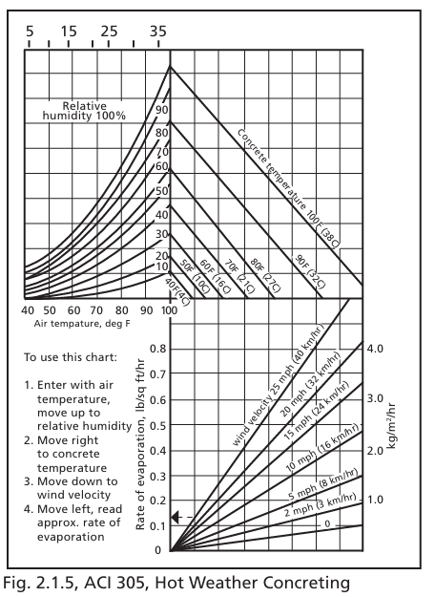

END OF GUIDE SPECIFICATION