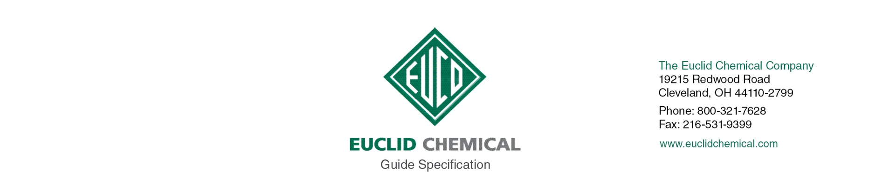
AQUASEAL EPOXY SYSTEM

The AQUASEAL family of products are two-part, 100% solids epoxy systems specifically designed for underwater applications on concrete or masonry surfaces. These products are suitable for applications in both fresh and saltwater. AQUASEAL MV is a high build protective coating for structures below water. AQUASEAL LV is a low viscosity version that can be mixed with aggregate to form a mortar for repair or can also be used “neat’’ for crack repair using pressure injection techniques.

{Note to Specifier: The paragraphs below are meant to be incorporated into Parts 2 and 3 of a standard CSI 3 Part Format specification, project’s General Structural Notes or directly onto the plans. They must be carefully reviewed by a qualified design professional and edited to meet the particular requirements of the project at hand, assure compliance with any governing building codes, and coordinate with other specification sections and drawings.}

PART 2.0: PRODUCT

2.__ UNDERWATER EPOXY

A. Epoxy Resin for Underwater Use: Two component, 100% solids epoxy, designed for under water use in both fresh water and salt water environments. Products shall conform to the following standards and exhibit the following properties:
1. [LV] ASTM C 881 Types III, Grade 1, Class C.
2. [MV] ASTM C 881 Types IV, Grade 2, Class C.
3. [GEL] ASTM C 881 Types IV, Grade 3, Class C.
4. Minimum 7 day compressive strength of 7,000 psi per ASTM C 109
5. Minimum 2,200 psi Bond Strength
6 Product:
a) Euclid Chemical Company (The); AquaSeal [LV] [MV] [GEL]
www.euclidchemical.com

B. Manufacturer shall have ISO 9001 Quality Certification. To ensure compatibility all admixtures shall be from the same manufacturer.

PART 3.0 EXECUTION

3.___ SURFACE PREPARATION

A. Concrete Removal: Remove all loose and unsound concrete per ICRI Guideline 310.1R “Guide for Surface Preparation”
1. Unsound concrete surface areas shall have perimeter boundaries saw cut to minimum depth of ¼ inch or less if such depth will cause saw to come in contact with embedded reinforcing steel. Saw cuts shall be made perpendicular to the concrete surface and all concrete removal boundaries shall be straight and aligned parallel to opposite boundary edges resulting in repair areas that are rectangular in shape.
2. All concrete shall be removed from within repair boundary to minimum depth of ¼ inch. Provide a surface with suitable profile for bond, as defined in repair mortar manufacturer’s written recommendations. If delaminations, cracking, or unsound materials exist beyond minimum removal depth, then removal shall continue until all unsound, delaminated, or cracked concrete has been removed from cavity.

B. Preparing Reinforcing Steel: Clean and prepare any exposed embedded reinforcing steel per ICRI Guideline 310.1R. “Guide for Surface Preparation”
1. Where ½ or more of diameter of reinforcement steel is exposed either by existing conditions or concrete removal, bond between the concrete and reinforcing steel is broken, or corrosion is present, the concrete shall be removed to provide a minimum ¾” clearance around entire perimeter of steel and along entire exposed length.
2. Clean all exposed reinforcing steel to bright steel, prior to installation of repair mortar.
a) Where section loss on a reinforcing bar is more than [insert number]%, or [insert number]% in two or more adjacent bars contact Engineer.

C. Concrete Preparation and Cleaning: Areas to receive concrete repair shall be structurally sound and free from deteriorated concrete, dust, dirt, debris, loosened concrete, paint, oil, efflorescence, laitance, and other contaminants, and shall have a minimum Concrete Surface Profile CSP equal to that recommended by the repair mortar manufacturer per ICRI Guideline 310.2.

3.___ EPOXY REPAIR MORTAR APPLICATION:

A. Mix and apply underwater epoxy system per manufacturer’s published recommendations.

